**SETTING UP APPLICATION**

Some Prerequisites:

1. Windows 10/11
2. SQL Server
3. SQL Server Management Studio

Setting up Database:

1. In the Setup folder, the user will find a .bak file. This file is empty and only contains the structure of the database.

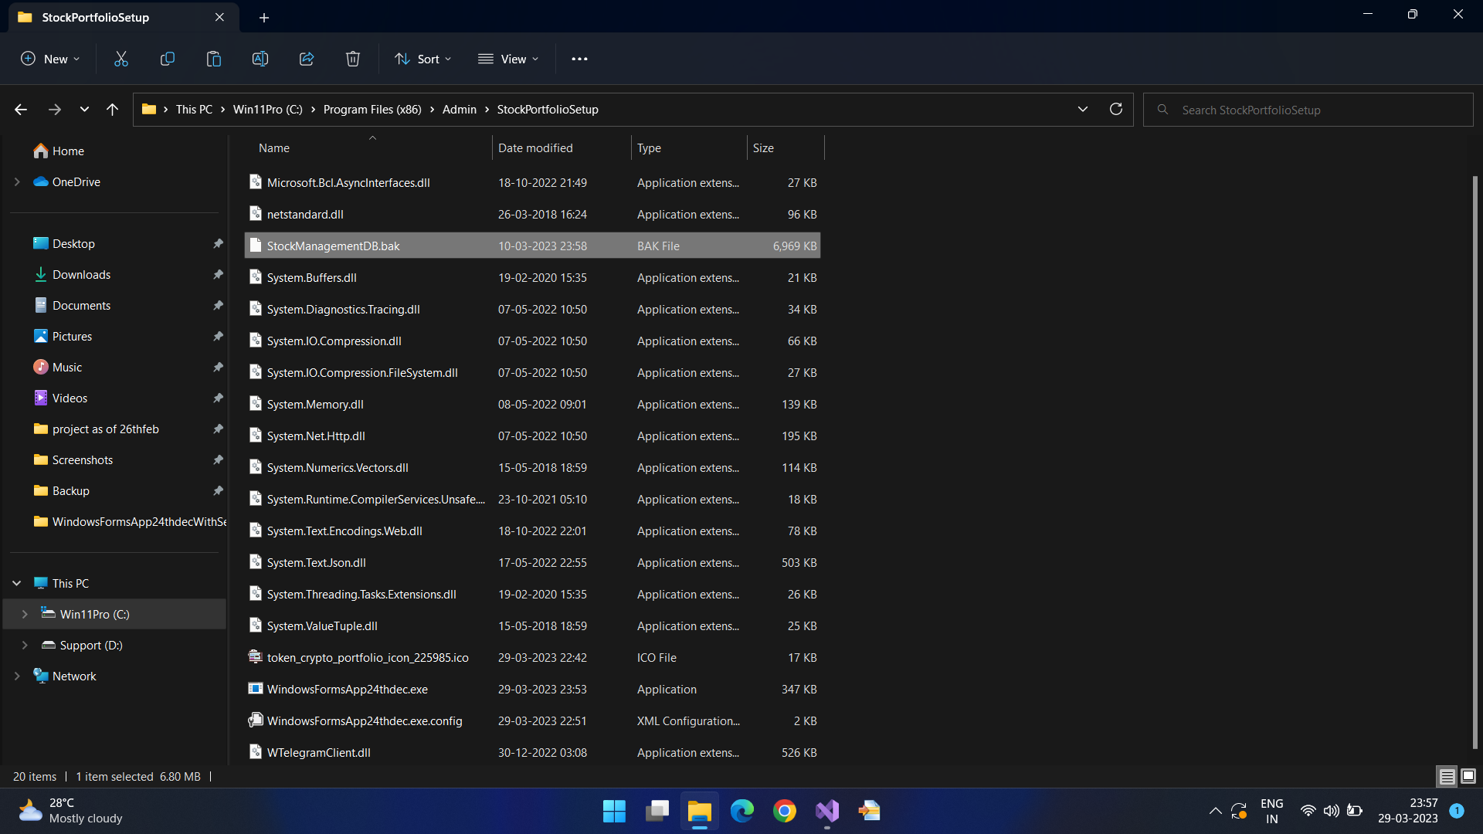

1. The user must login to SQL Server Management Studio, and right click on the Database folder

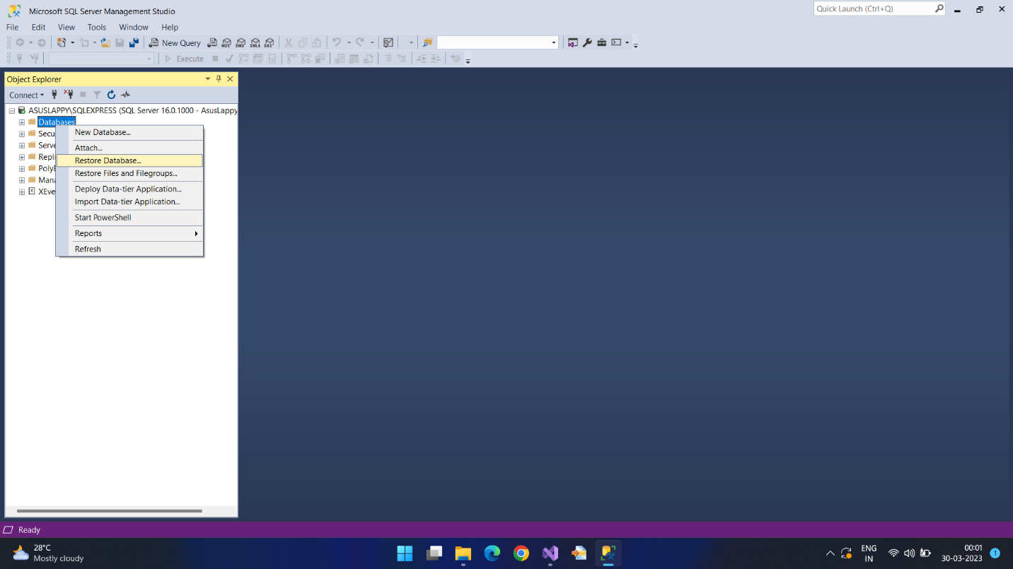

1. Click on the Restore button.

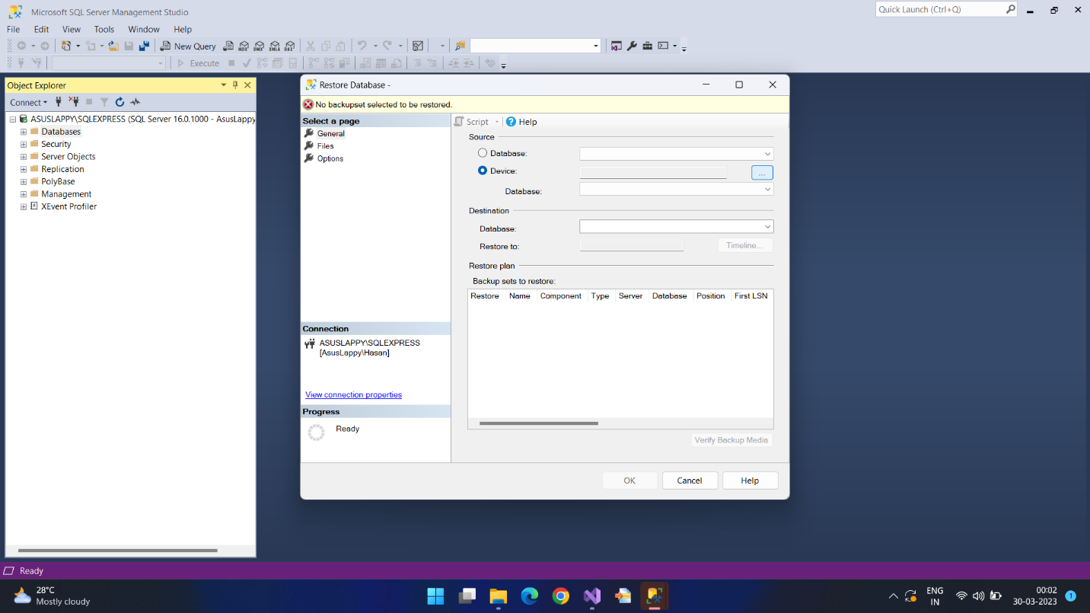

1. Select the .bak file from the Setup folder.

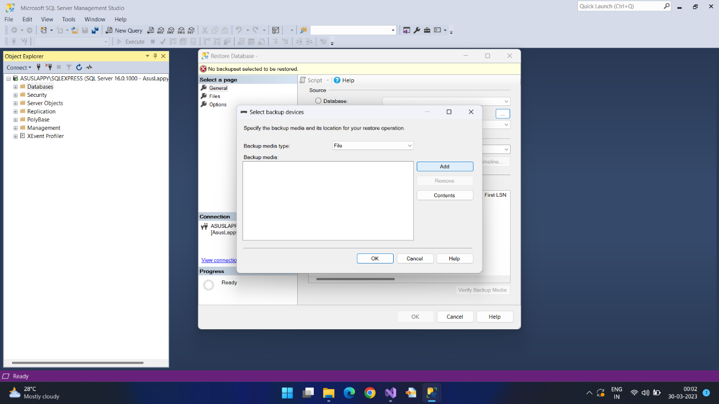

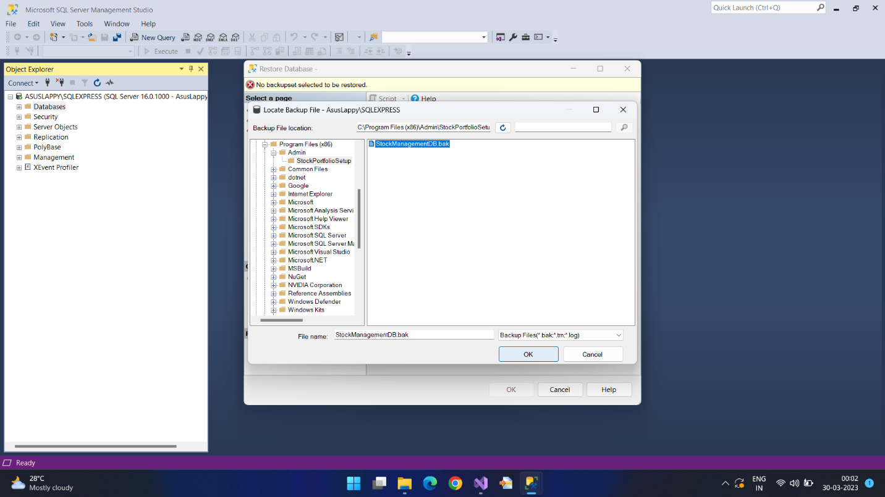

1. Click on the OK button twice. The backup is complete.

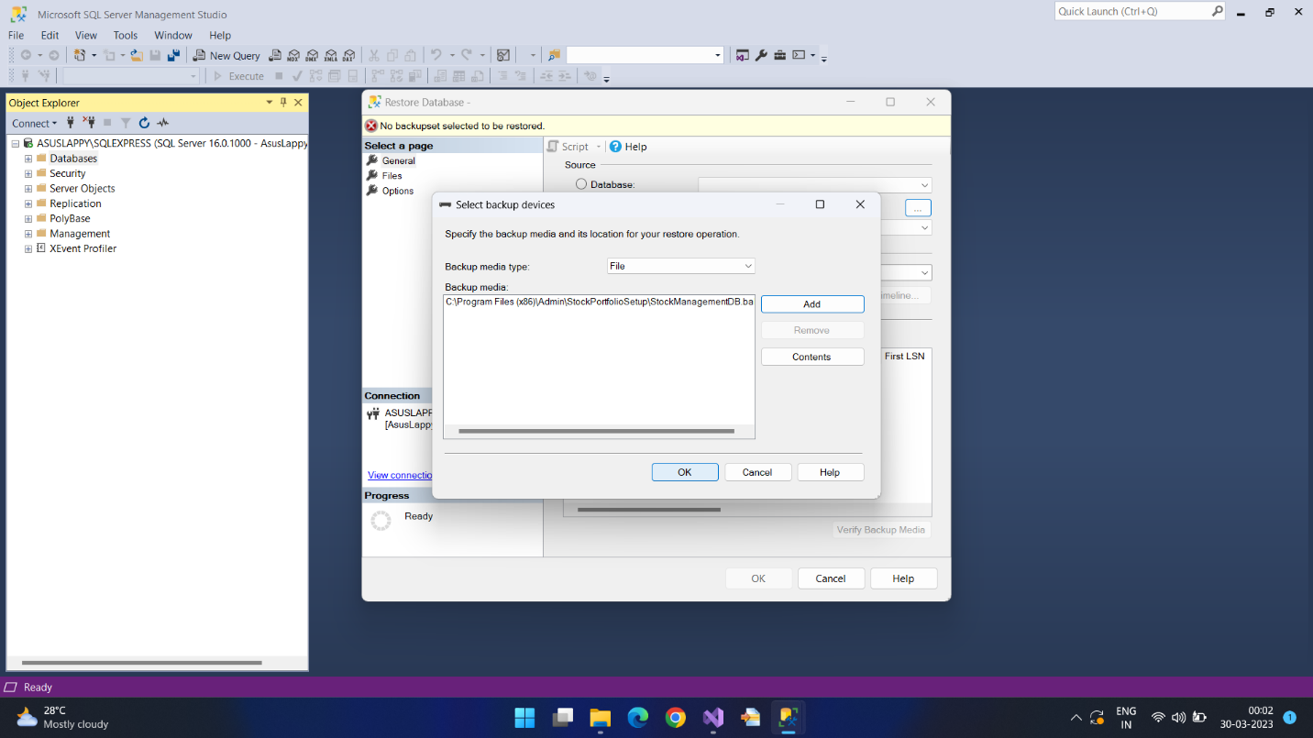

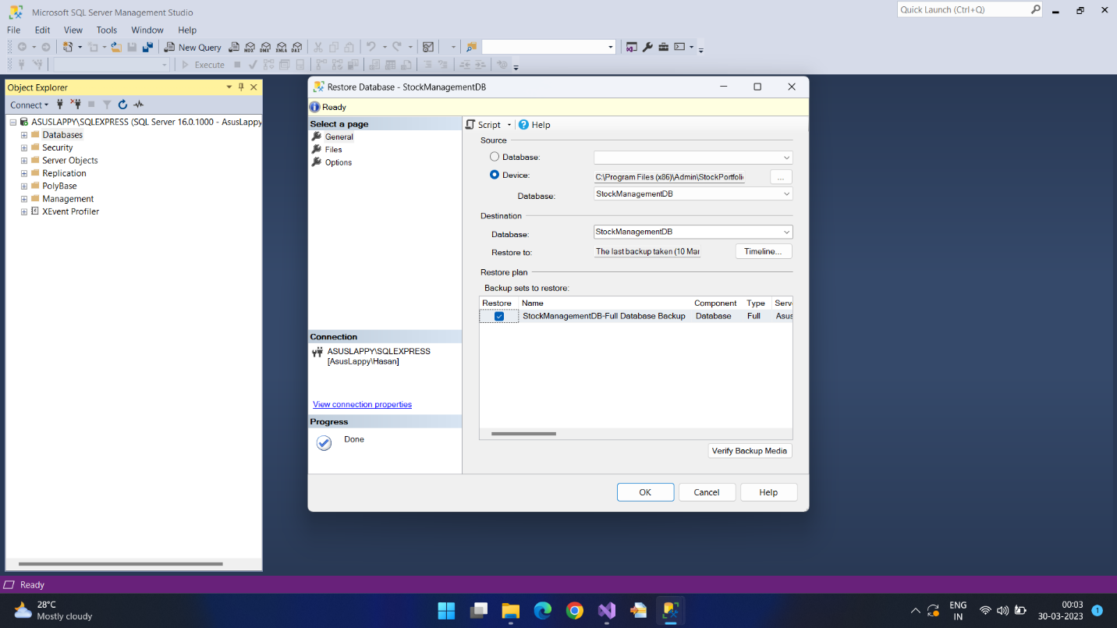

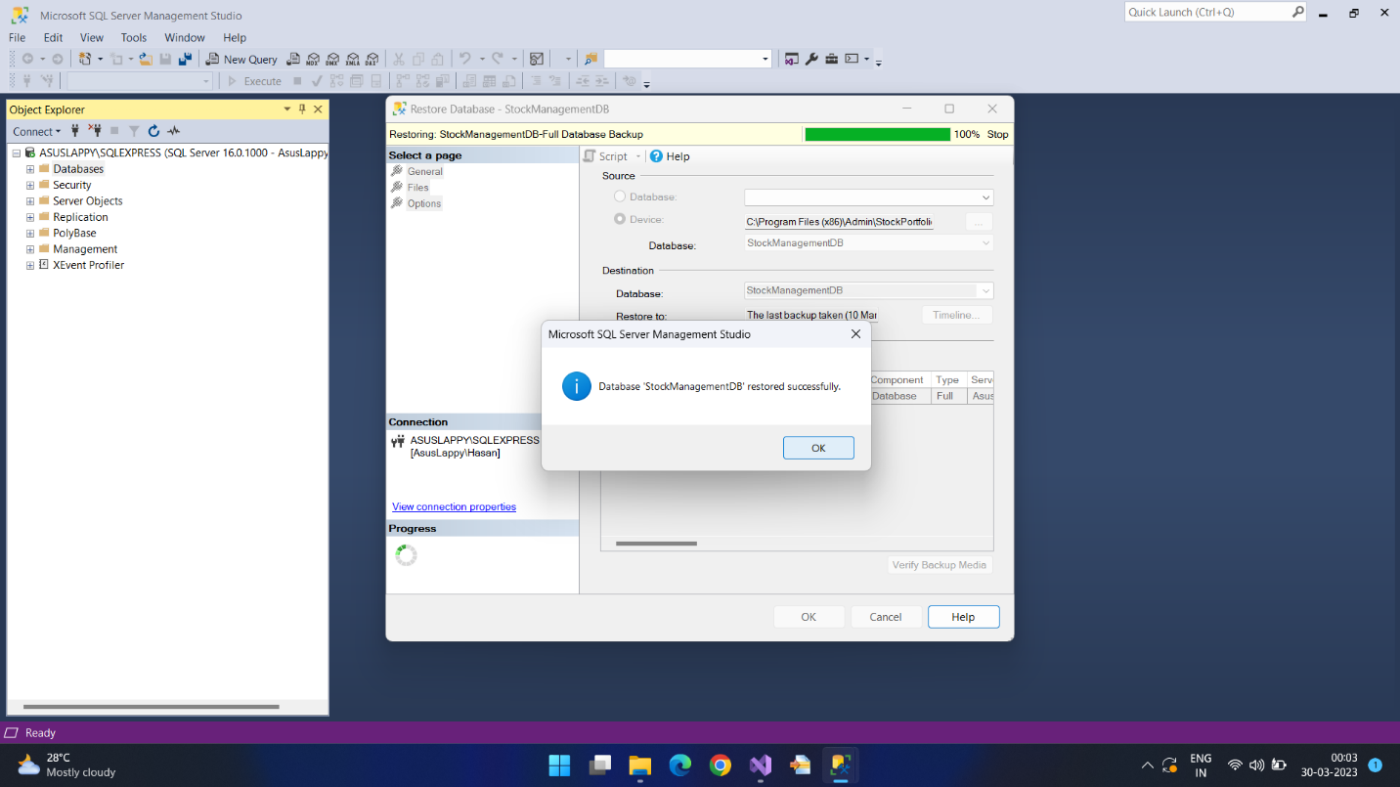

Installing the Application:

1. Go to the Setup folder, find the Release folder within it and run the setup.exe file. The wizard will guide you through the installation process.

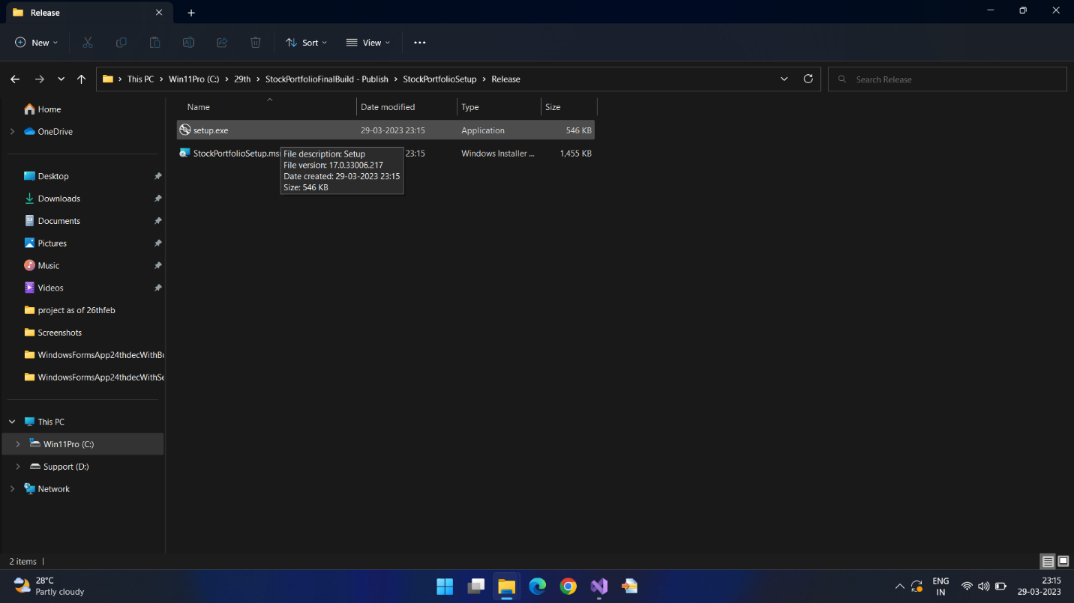

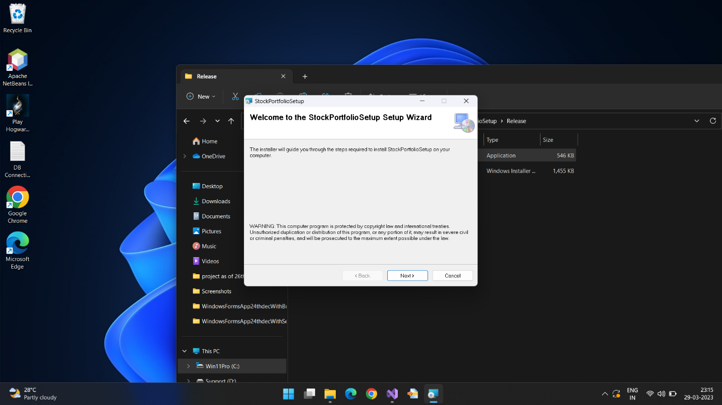

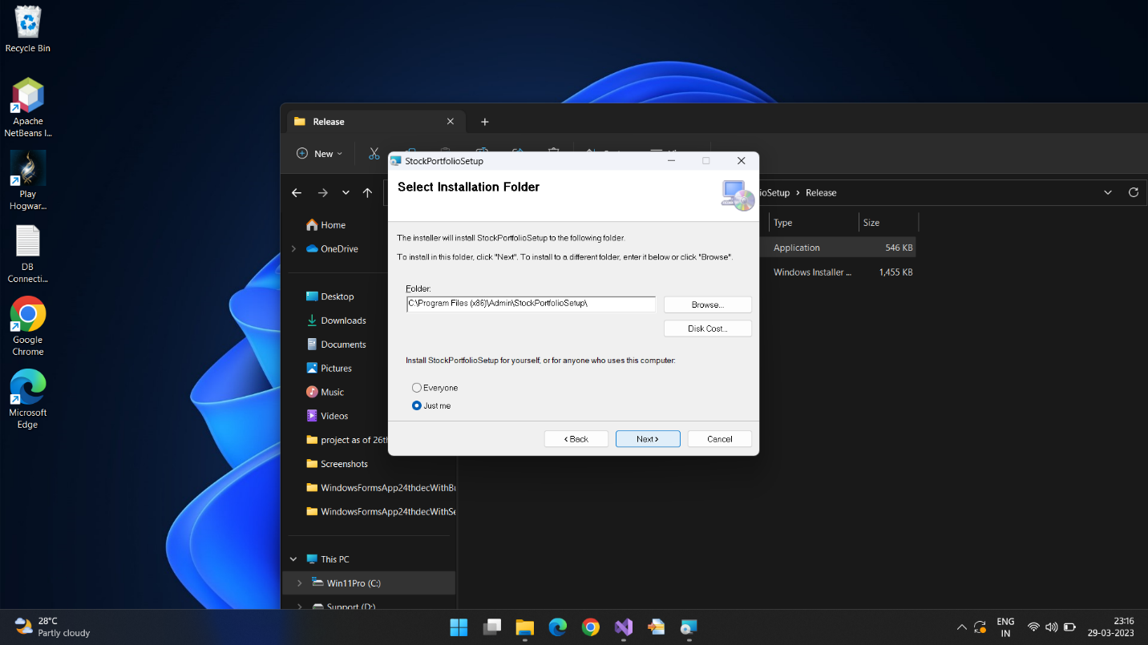

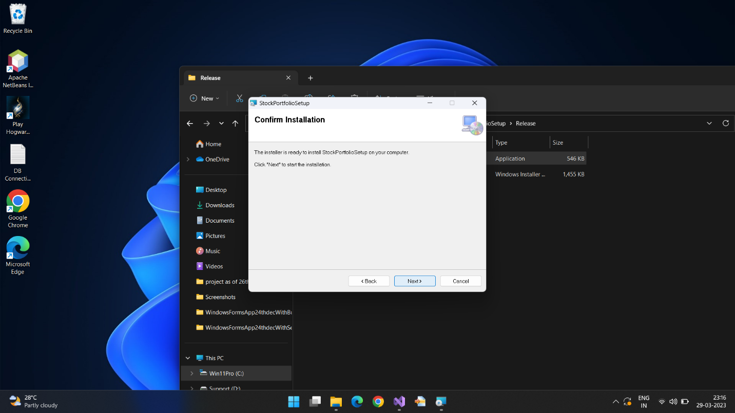

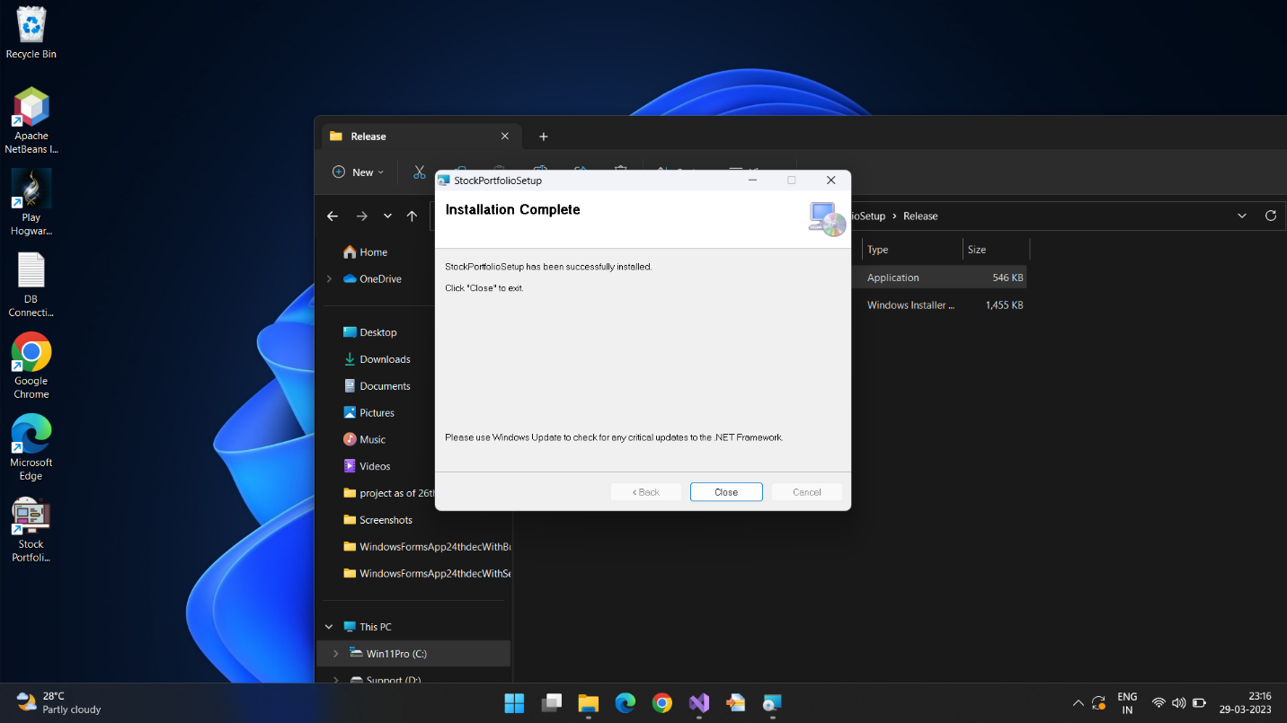

Change Connection String:

1. In the Application folder in your System Programs (x86) folder, find the file ending with the extension .config. Open it using the notepad. Retrieve the Connection String from SQL Server and paste it in the location as shown below in the screenshot.

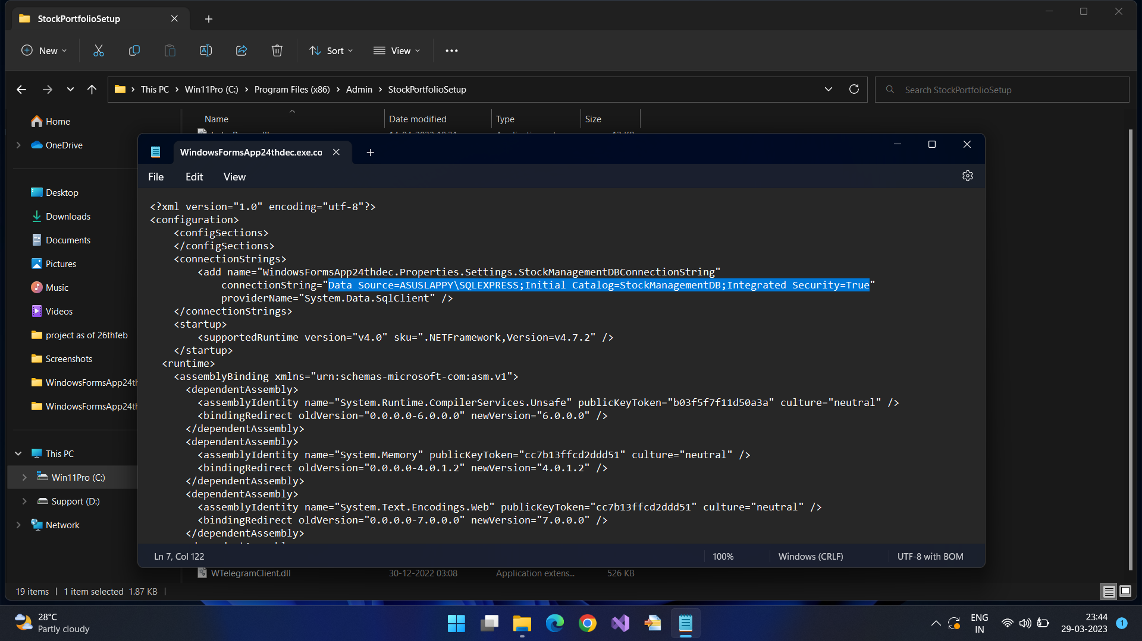

Sourcing Data:

1. There is sample data included with the download files, a file for the Stock Study Pane, and another file for the Portfolio Pane.
2. To source data on your own, for the Stock Study Pane, find a tab separated Text/CSV file from the official NSE website, or any tab separated data consisting of the following fields: Company Name, Industry, Symbol, Series and ISIN Code. The file provided as sample data is tab separated and has a .txt extension.
3. To source data for the Portfolio Pane on your own, find comma separated CSV file data from the Zerodha portal consisting of your current holdings, or any comma separated CSV holdings data with the following fields: Instrument (Symbol), Quantity, Average Cost, LTP, Current Value, Profit & Loss, Net Change and Day Change. The file provided is comma separated and has a .csv extension.

**USER MANUAL**

**OPENING THE APP FOR THE FIRST TIME**

1. Open the application. The app opens up with the following view:

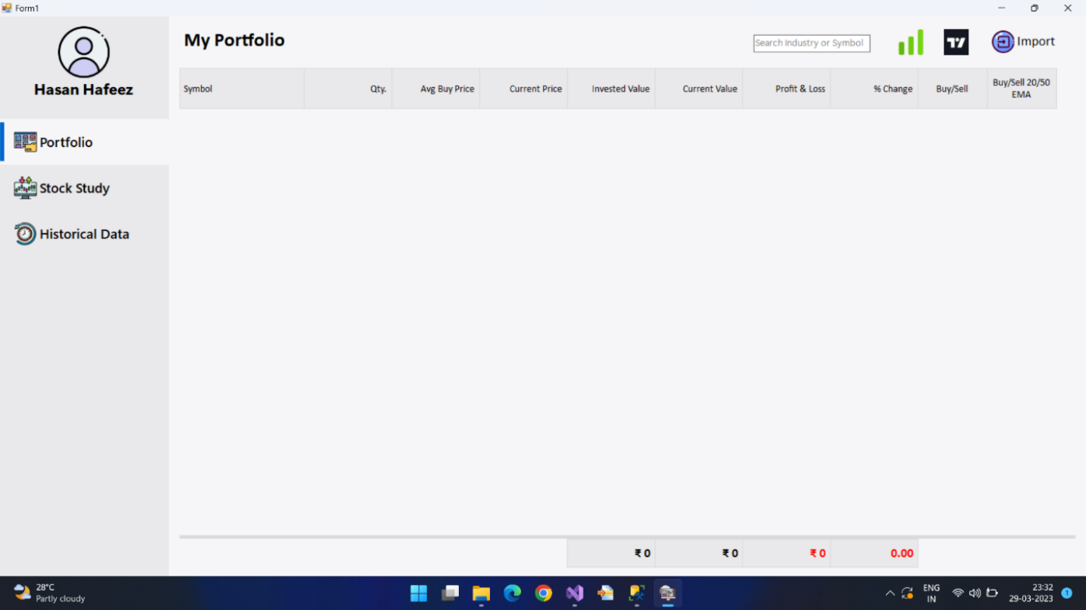

1. If you click on the Stock Study Button, you see this:

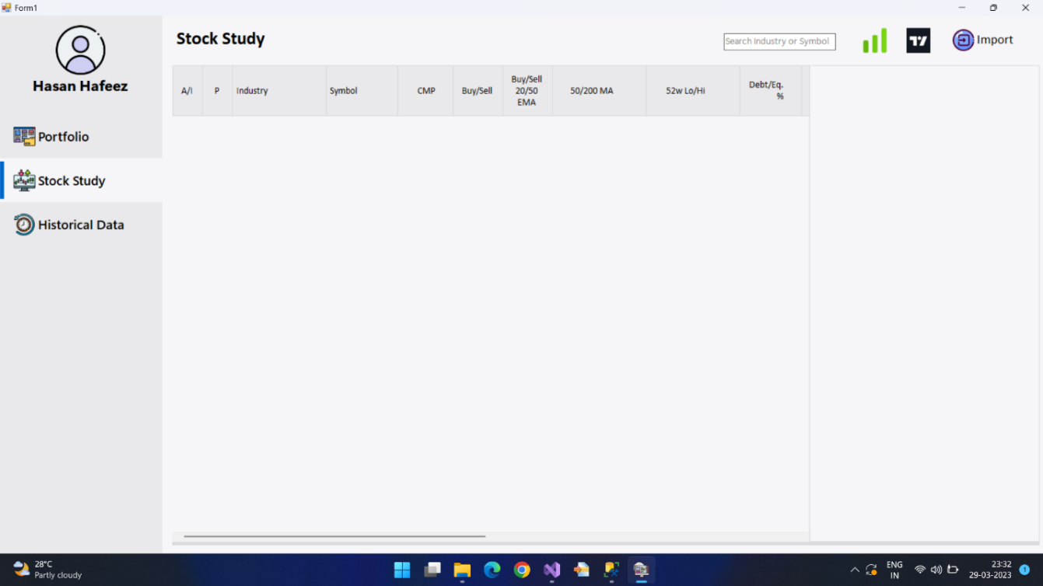

1. And if you click on the Historical Data Button:

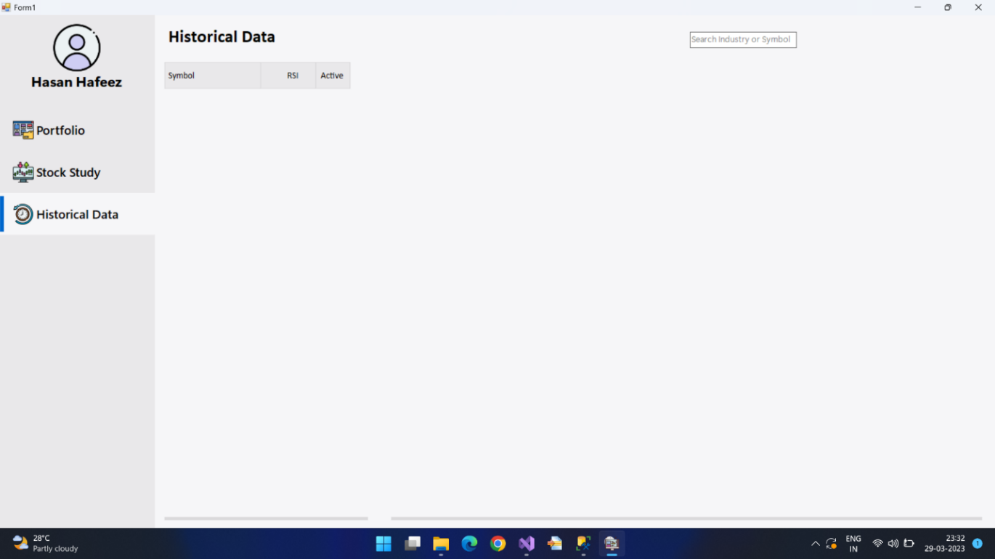

**PERFORM AN IMPORT OPERATION (Stock Study Pane):**

1. To perform your first Import, go to the Stock Pane as click on the Import Button

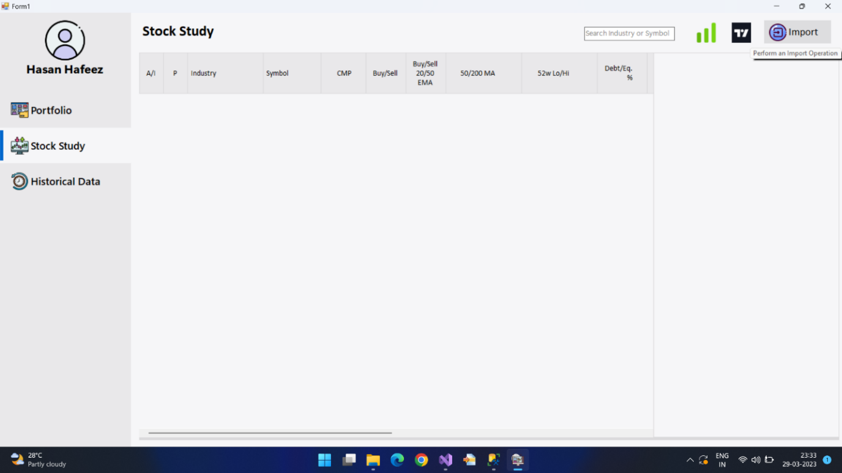

1. Choose an appropriate CSV file

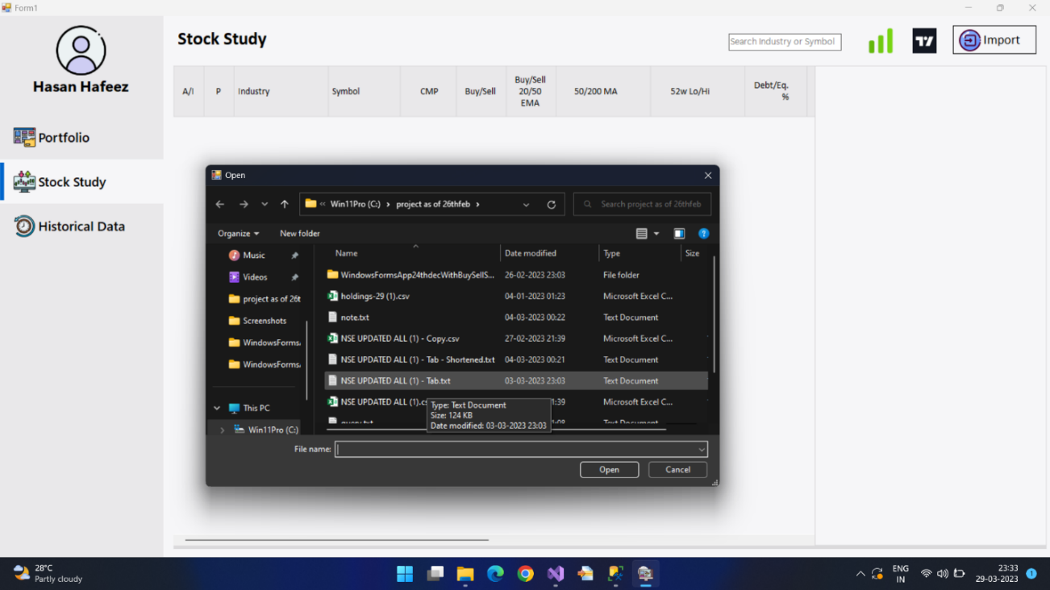

1. Now, wait for the Import operation to complete. The DataGridView is now filled with the list of stocks from the CSV file. No updates will take place until stocks are set to active, or until a Portfolio Pane Import is done.

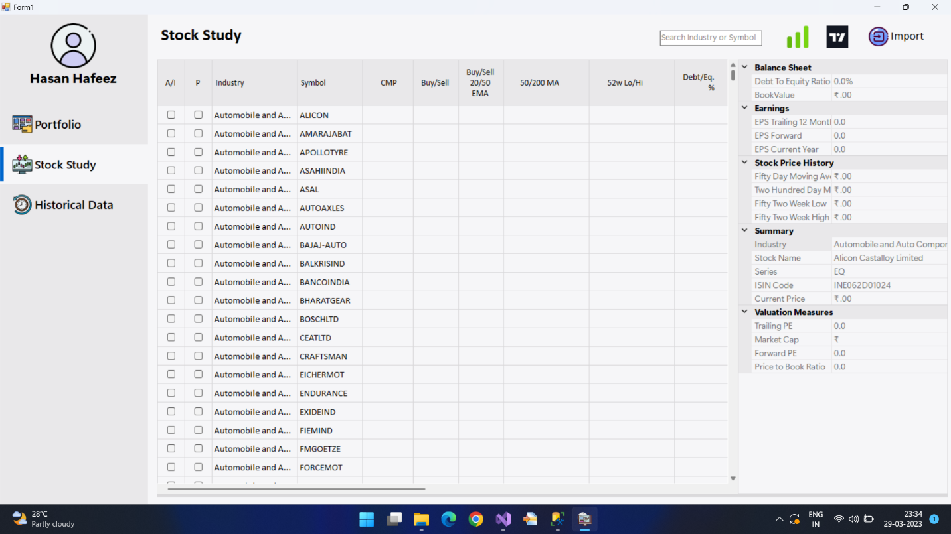

1. A view of the Historical Data Pane after the Import:

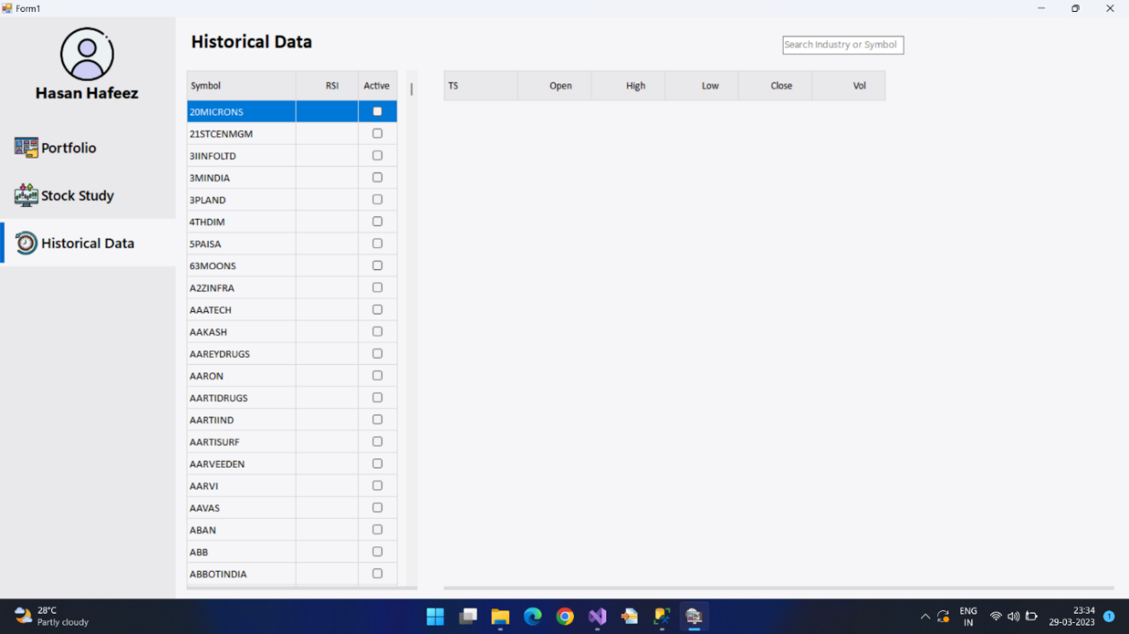

**PERFORM AN IMPORT OPERATION (Portfolio Pane):**

1. To perform your first Import operation, go to the Portfolio Pane and click on the Import Button.

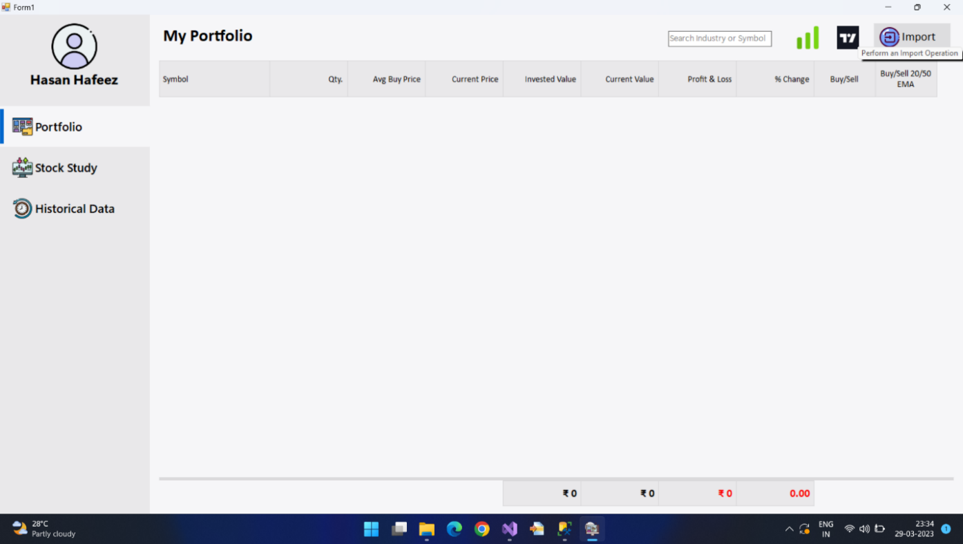

1. Choose an appropriate CSV file

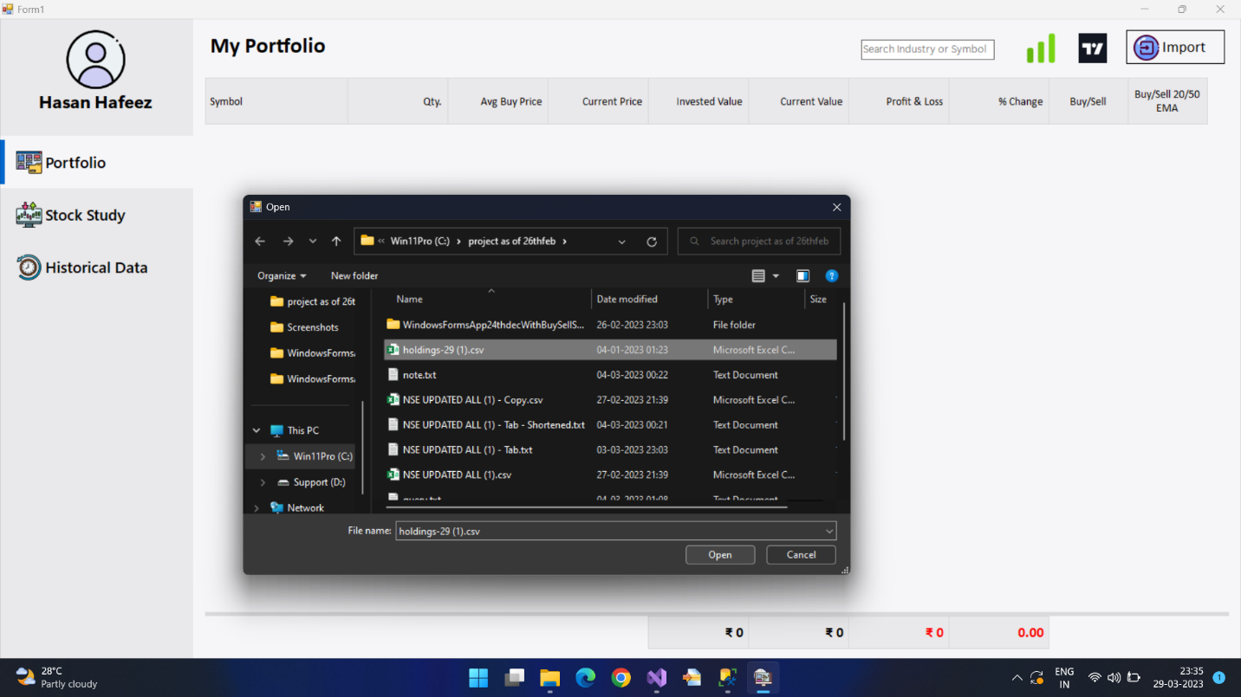

1. Wait for the Import Operation to complete. You will see the DataGridView in the Portfolio Pane filled with stocks from the CSV file.

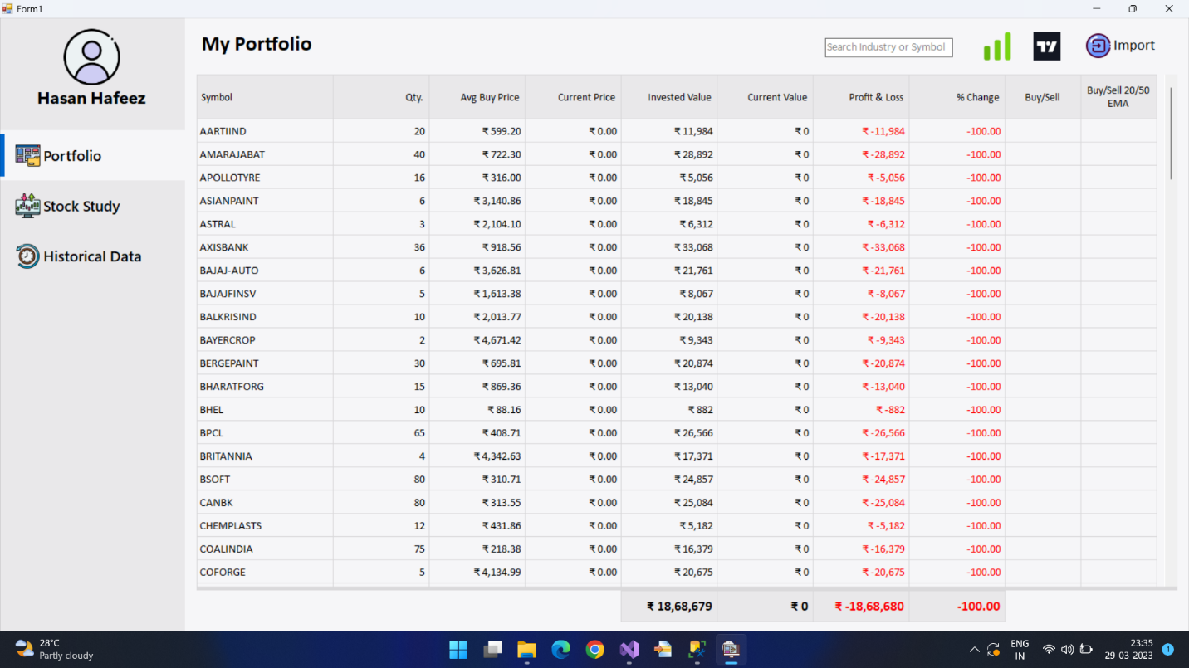

**WAITING FOR AN UPDATION:**

1. At every set interval of time, an update process is triggered in the app. There is a separate interval of time set for the Stock Study/Portfolio pane, and a another one for the Historical Data Pane. After this, you will see the Stock table filled with values or data retrieved from the YahooFinanceApi which are various parameters pertaining to different stocks set to active for regular updates. The stock pane’s gauges will be painted, and even buy and sell signals will be visible after the database’s stored procedures are executed. The portfolio pane’s DataGridView has proper values for its Current Price, Current Value, Profit & Loss and Percent Changed columns, and even buy and sell signals are visible after the stored procedure is executed. The Historical Data Pane has historical data visible for all active stocks for the past 1 year.
2. A View of the Portfolio Pane after updation:

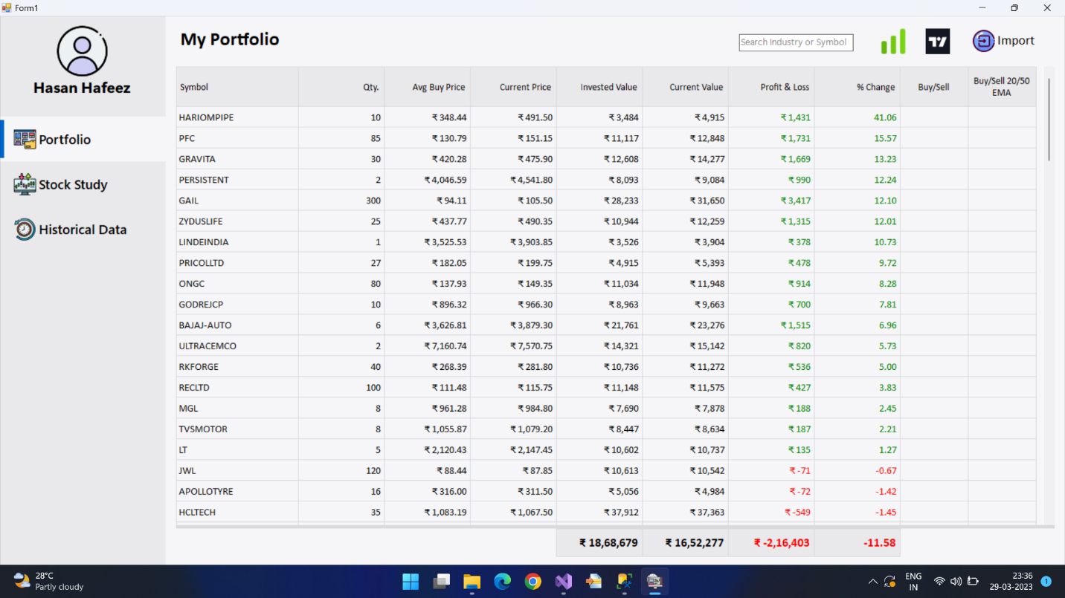

1. A View of the Stock Pane after updation:

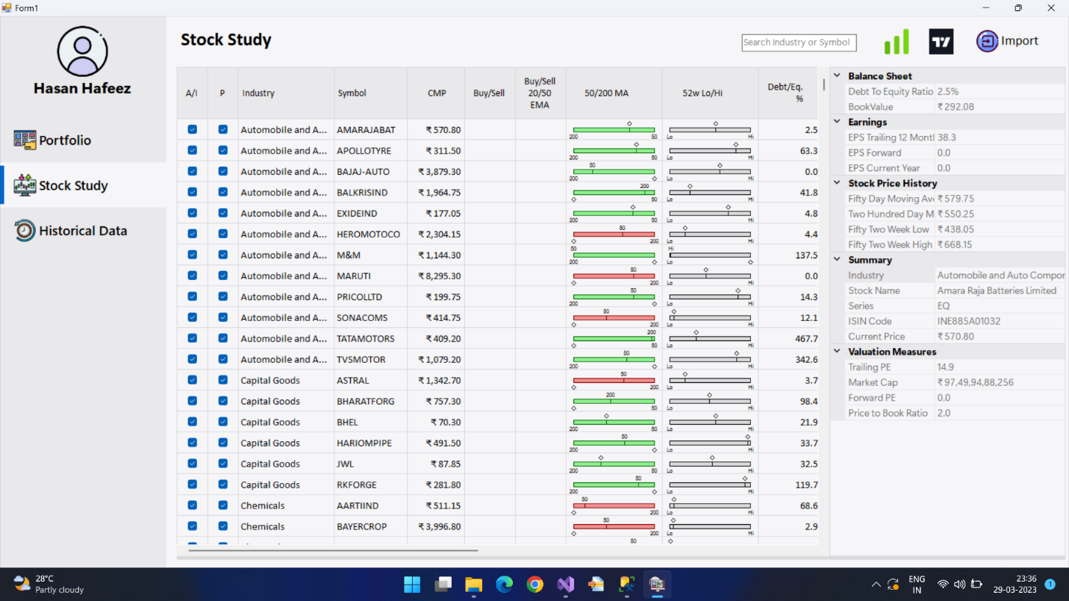

1. A View of the Historical Data Pane after updation:

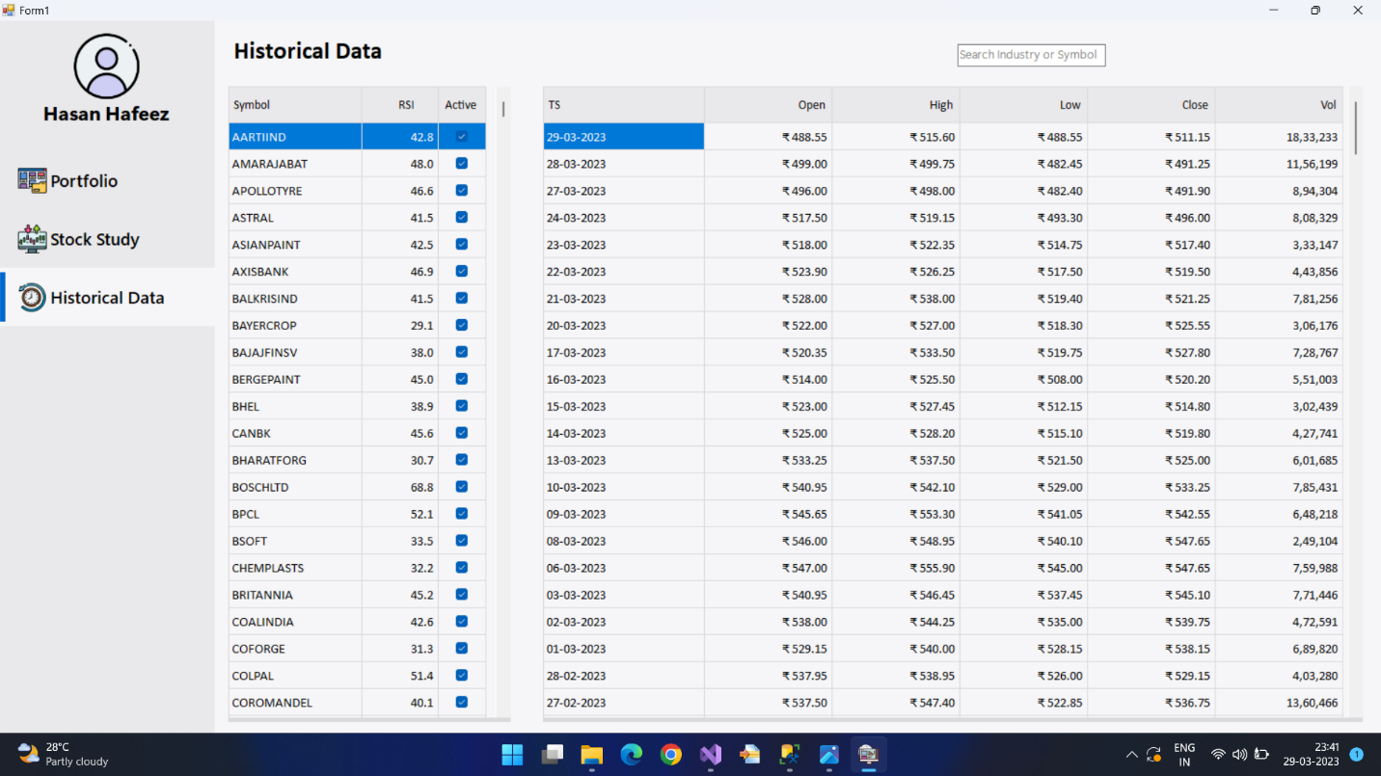

1. A View of the Portfolio Pane after the stored procedure is run:

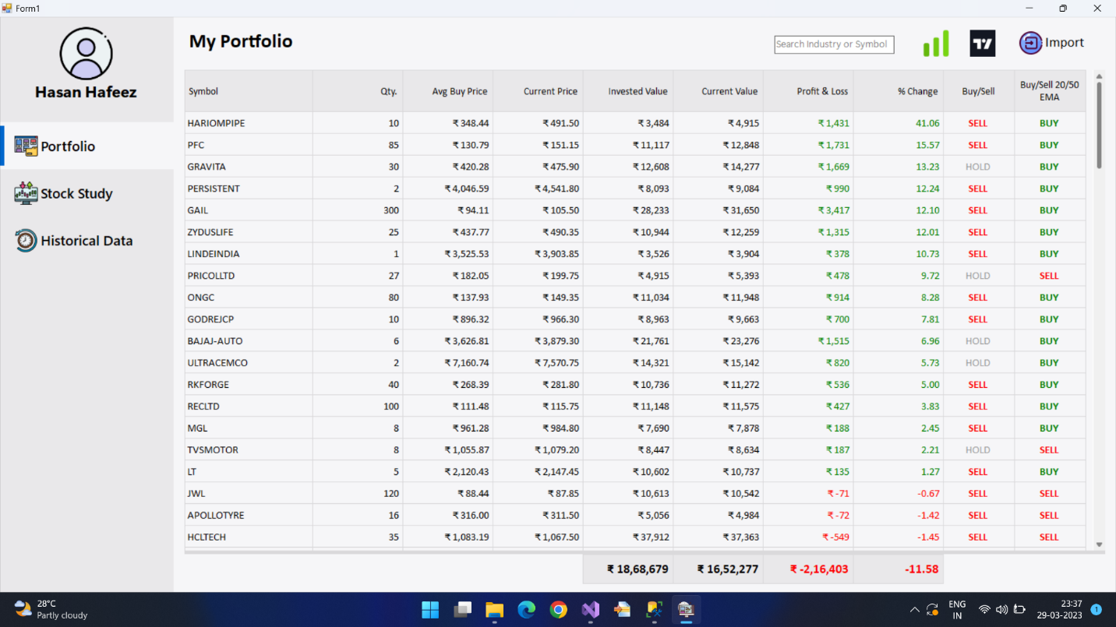

1. A View of the Stock Study Pane after the stored procedure is run:

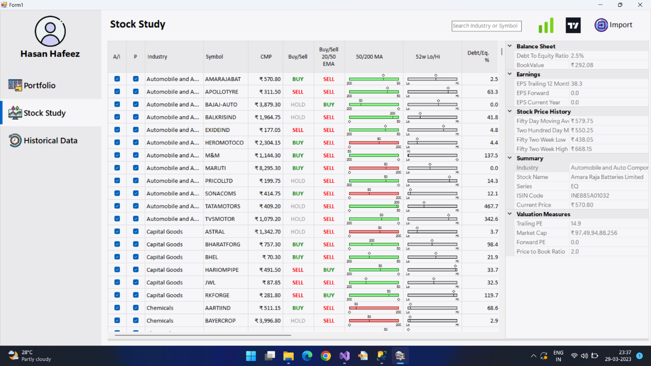

**REGULAR USE OF APPLICATION:**

1. Using the Portfolio Pane

* You can select rows in the DataGridView, both to copy the data, and to use the Screener and TradingView.

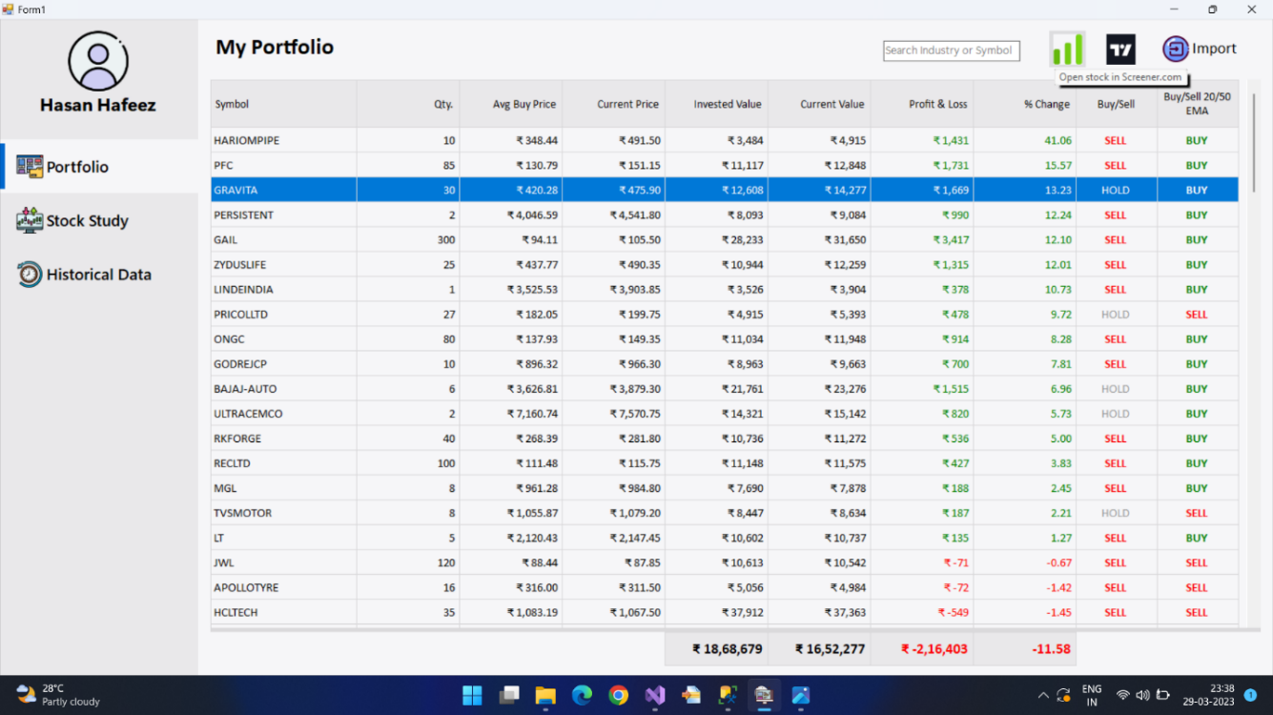

* TradingView.com:

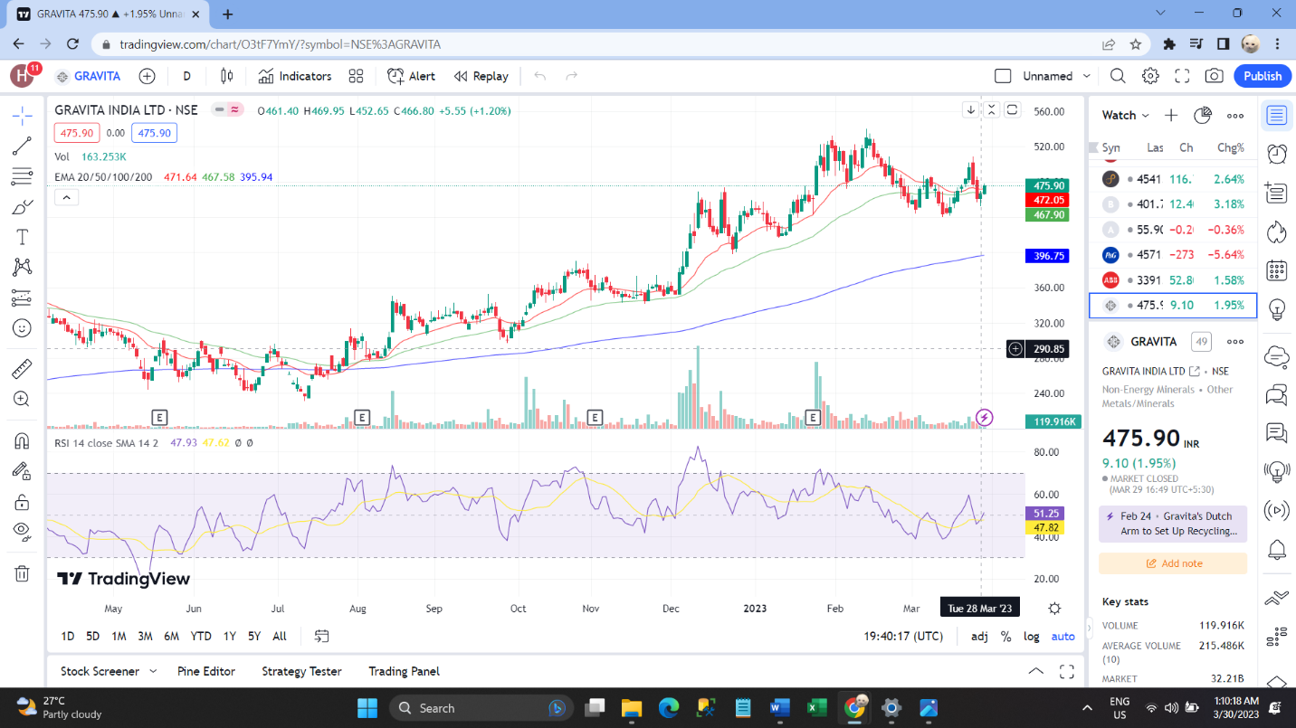

* Screener.com:

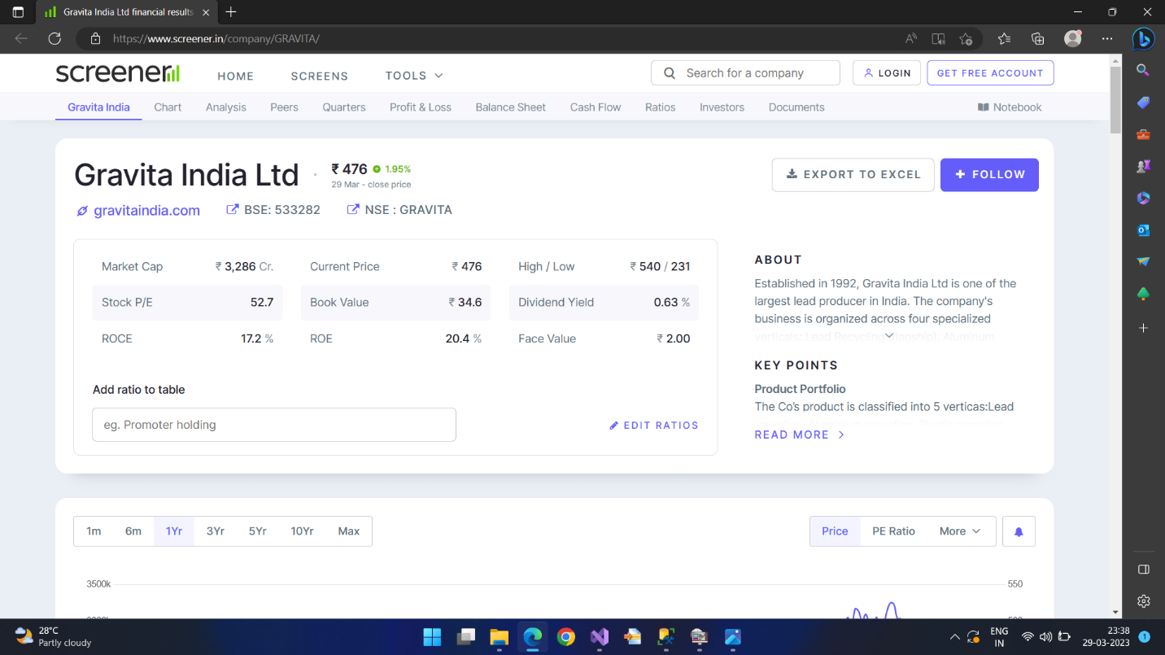

* The search bar on the top makes filtering easy.

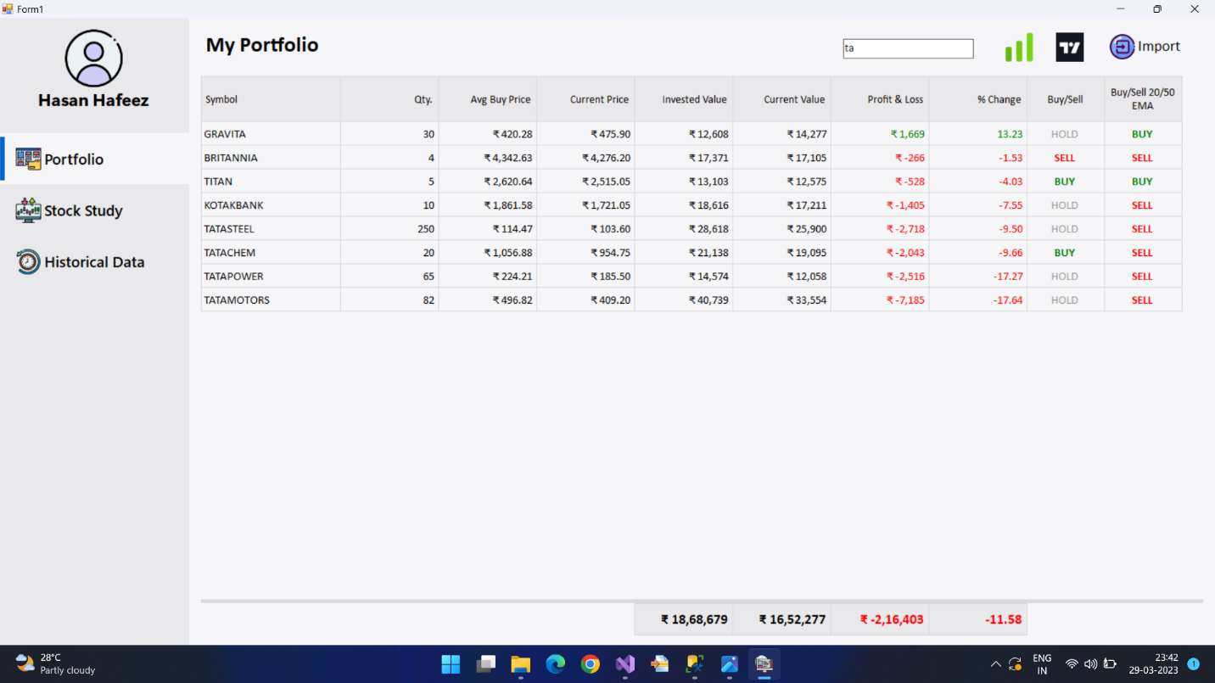

1. Using the Stock Study Pane

* You can select rows in the DataGridView, both to copy the data, and to use the Screener and TradingView, just like you can in the Portfolio Pane.
* Another feature that comes with row selection in the DataGridView is the ability to view extra details about the stock in the PropertyGrid in the right hand side of the Stock Study Pane. The data displayed by it changes to match the currently selected stock.

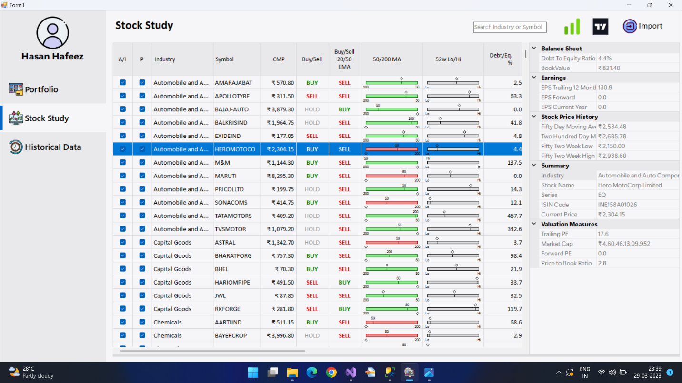

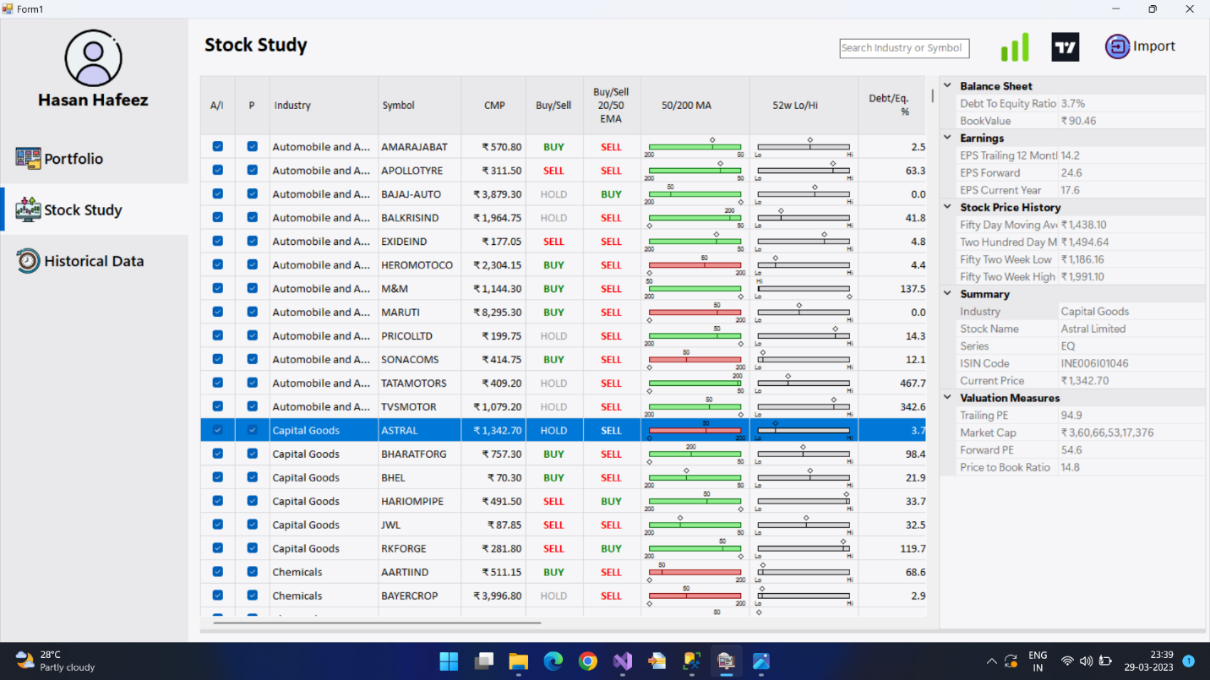

* If you select a stock that is not currently set to active (i.e., not eligible for regular updates), the PropertyGrid is empty and the DataGridView displays very limited information.

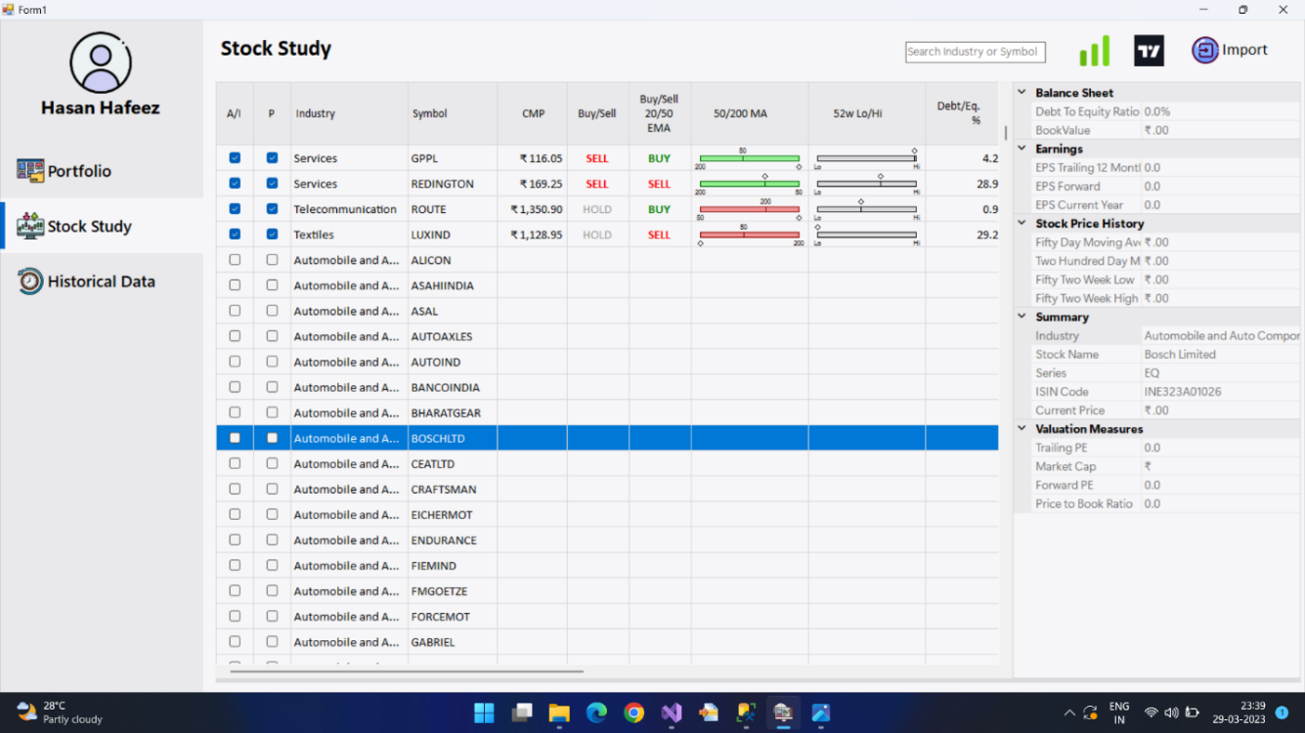

* You can select the checkbox in the ‘A/I’ column of DataGridView in the Stock Study Pane. This will change the active state of the stock, making it eligible for regular updates. Select the checkbox and wait for the interval to pass. You will see the stock updated with data fetched from the API.

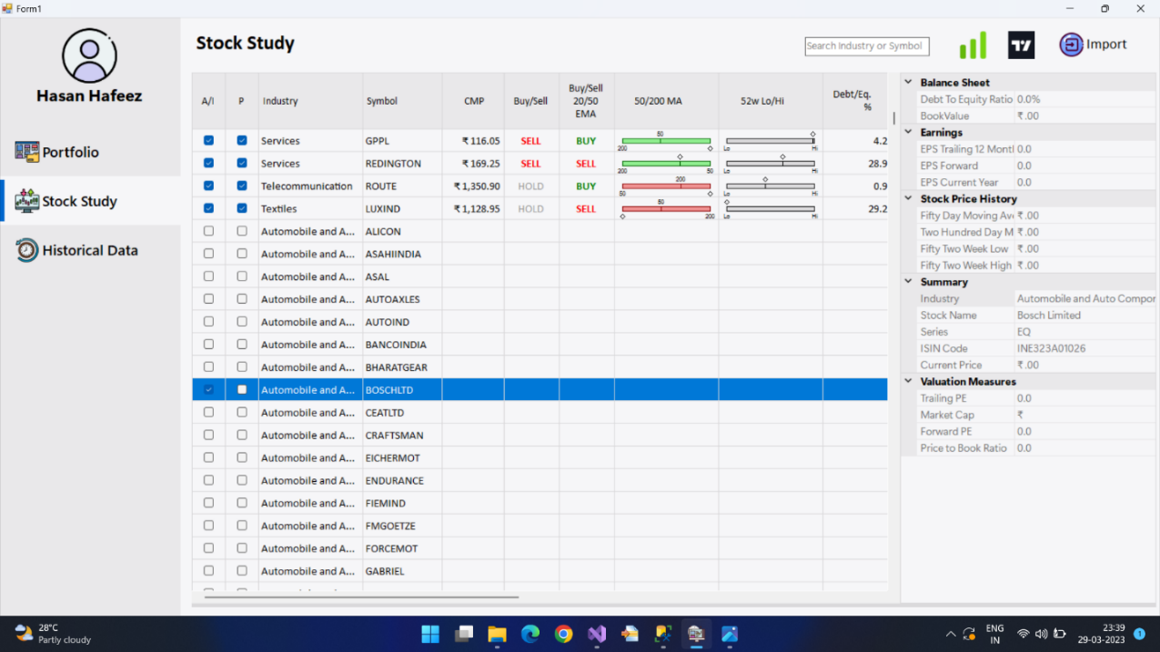

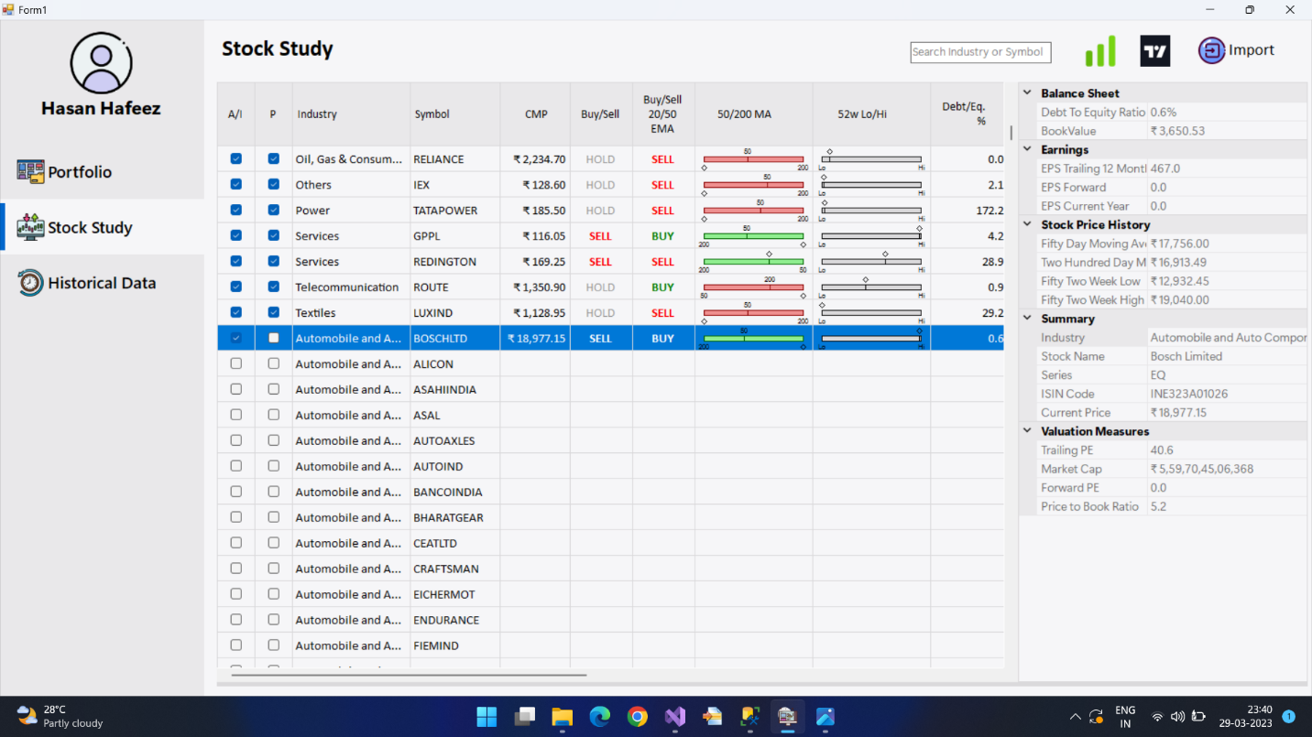

* The Stock Study Pane has TradingView and Screener Buttons as well, that work the same way as the TradingView and the Screener Buttons from the Portfolio Pane.



* The search bar on the top can filter through the DataGridView, making discovery easier.

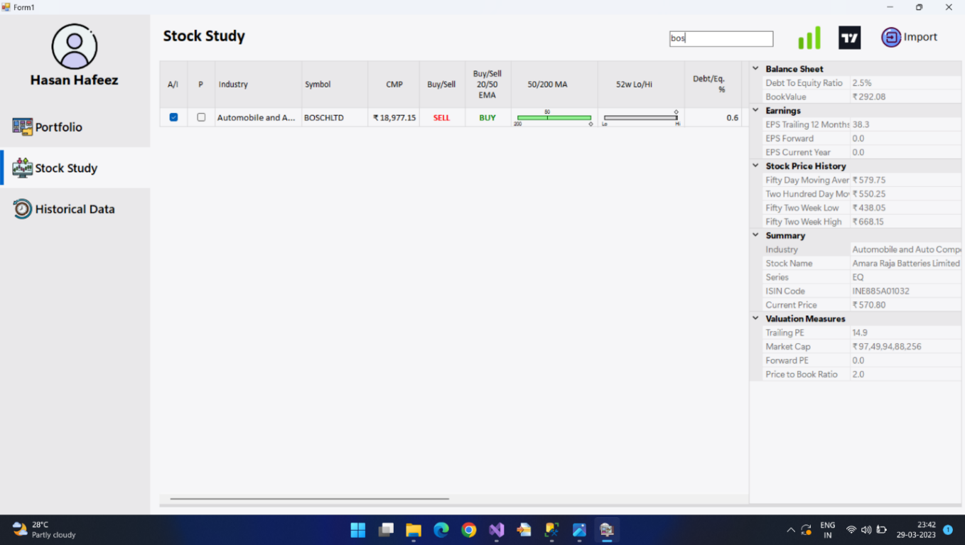

1. Using the Historical Data Pane

* You can select rows on both DataGridViews. The one on the left shows Symbols, Rsi values, and whether the stock is set to active or not. When a row is selected on the left DataGridView, the DataGridView on the right hand side of the pane is updated to reflect stock history data for that particular symbol/stock.

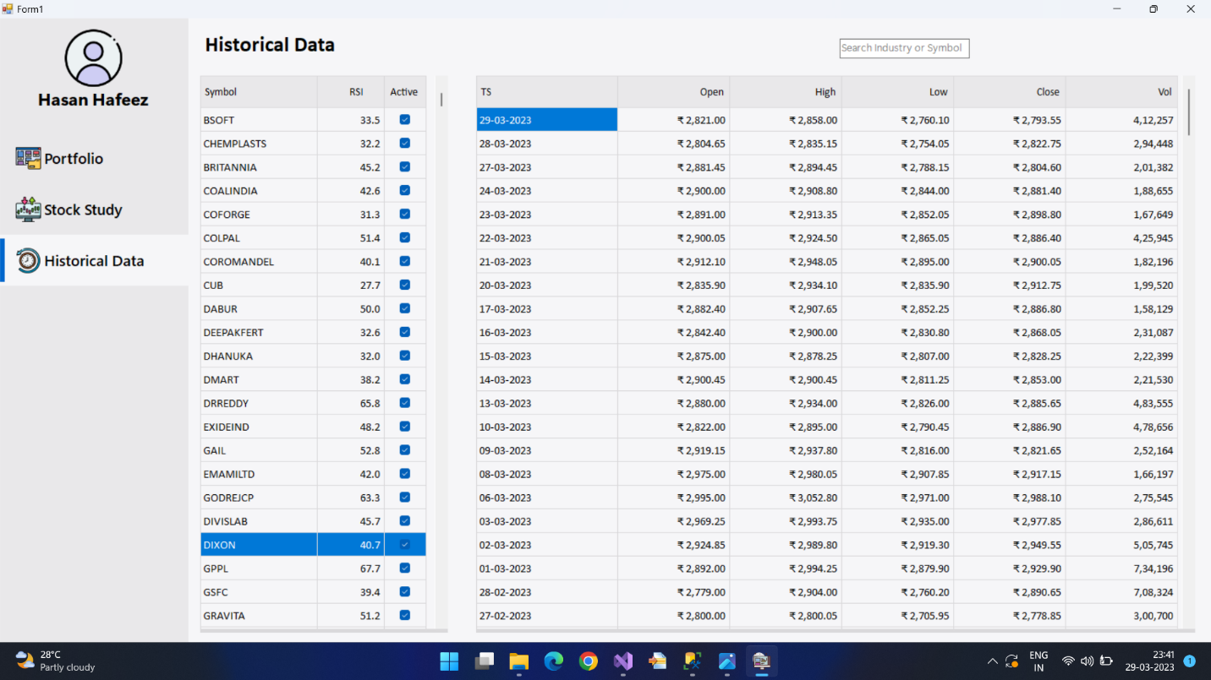

* Inactive stocks either have no historical data, or have historical data from the last time they were set to active and the checkbox for them was toggled to off.

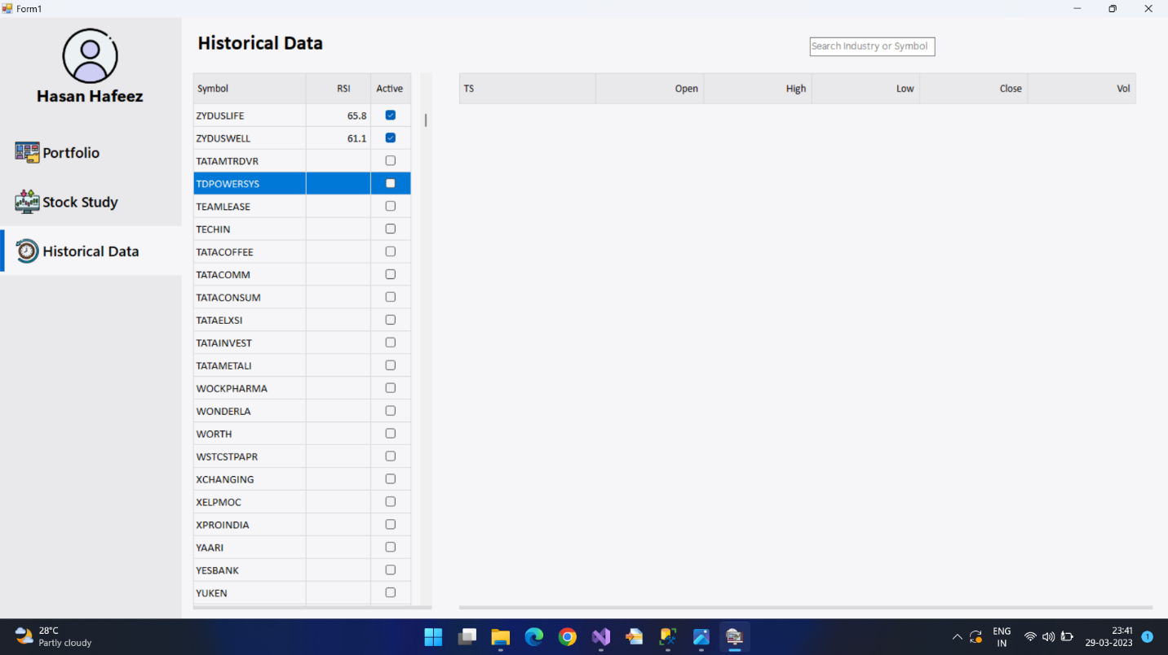

* If a new stock in the Stock Study Pane is set to active, during the next update process in the Historical Data Pane, historical data for the new stock is retrieved as well.

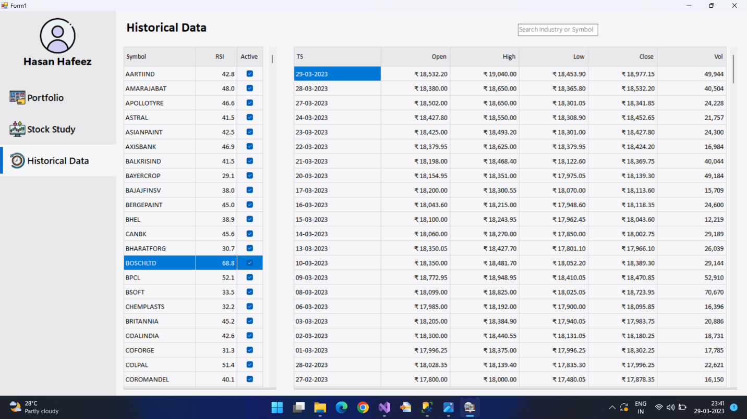

* After the Stored Procedures from the database are run, RSI values are visible as well.



* The search bar filters through records in the left DataGridView.

